

RIJA MUNAWAR ALI (68452)
HIRA ZULFIQAR (69759)
NIDA MUNAWAR ALI (68453)

CCA

 | Assessment of CCA
Mapped Gas |  |  | Bloom Taxonomy
GA 2 |  |  | P3
GA 5 |  |  | C3
GA 10 |  |  | A3

Smart Parking Lot Management System

Introduction

The Smart Parking Lot Management System (Traffic Simulation Project) is a Java-based program that models traffic flow using intersections, roads, vehicles, and traffic lights. The city map is represented as a graph, and the system calculates the shortest path for vehicles from their start point to destination using Dijkstra’s Algorithm. Traffic signals control vehicle movement (RED/Green), and the simulation shows how vehicles travel step by step. At the end, the system displays the routes taken, total distance traveled, and road traffic loads, making it useful for understanding traffic management, congestion control, and smart city planning.

Motivation

With the rapid growth of urban areas, managing traffic congestion and efficient parking has become a serious challenge. Traditional systems often fail to handle increasing vehicle loads, leading to delays, fuel wastage, and frustration. This project is motivated by the idea of creating a smart, automated system that can simulate traffic movement, optimize routes using algorithms, and manage parking in an efficient way. Such systems contribute towards the vision of smart cities, where technology is used to improve daily life and reduce traffic-related problems.
Problem Statement
In modern cities, increasing numbers of vehicles create challenges such as traffic congestion, inefficient parking space utilization, and longer travel times. Traditional parking and traffic systems lack automation, real-time decision-making, and route optimization, which results in unnecessary delays and fuel consumption. Therefore, there is a need for a smart and automated system that can efficiently manage vehicle flow, optimize routes, and track parking usage to ensure smoother transportation and better resource utilization.

Methodology

The Smart Parking Lot Management System is designed using a graph-based approach where intersections act as nodes and roads act as edges. Vehicles are assigned start and destination points, and the system applies Dijkstra’s Algorithm to calculate the shortest path. Traffic lights are simulated to control vehicle movement step by step. During the simulation, the system tracks vehicle routes, travel distance, and traffic loads on each road. Finally, the results provide insights into traffic flow and parking efficiency.

Functionalities
- Add Intersections & Roads – Create a network of roads and parking points.
- Shortest Path Calculation – Find the most efficient route for vehicles using Dijkstra’s Algorithm.
- Traffic Light Simulation – Manage vehicle movement with RED/GREEN signals.
- Vehicle Management – Assign start and destination points to vehicles.
- Step-by-Step Simulation – Show how vehicles move across intersections.
- Traffic Load Tracking – Record the number of vehicles passing on each road.
- Result Analysis – Display traveled distance per vehicle and traffic distribution.

Tools and Components
- Language: Java (using JDK for compilation and execution).
- IDE: Eclipse / IntelliJ IDEA / NetBeans for development.
- Data Structures: Graph (nodes = intersections, edges = roads), HashMap, PriorityQueue, ArrayList.
- Core Components:
  - Intersection (parking/road junction)
  - Road (connection with distance)
  - Traffic Light (RED/GREEN control)
  - Vehicle (moving cars)
  - Traffic System (simulation controller)

Conclusion
The Smart Parking Lot Management System demonstrates how graph-based algorithms, traffic lights, and shortest path calculations can be used to simulate vehicle movement and parking management. The project highlights efficient traffic flow, route optimization, and real-time monitoring of road loads. This system can be further enhanced with dynamic parking availability, sensors, and a user interface to make it more practical for real-world smart city applications.
FlowChart
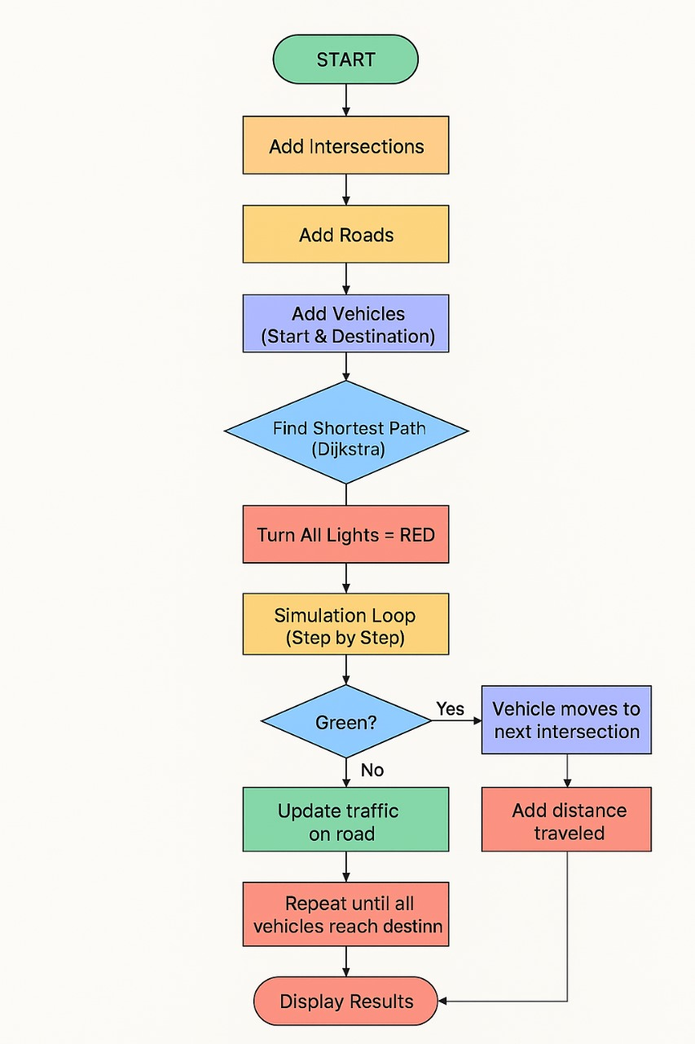CODE:
package CCA;

import java.util.ArrayList;
import java.util.Collections;
import java.util.Comparator;
import java.util.HashMap;
import java.util.HashSet;
import java.util.List;
import java.util.Map;
import java.util.Objects;
import java.util.PriorityQueue;
import java.util.Set;

public class Main {

static class Intersection {
String name;
List<Road> roads = new ArrayList<>();
TrafficLight light;

Intersection(String name){
this.name=name;
this.light = new TrafficLight();
}
void addRoad(Road road){
roads.add(road);
}

public boolean equals(Object o){
return this==o || (o instanceof Intersection i && name.equals(i.name));
}

public int hashCode(){
return Objects.hash(name);
}
}

static class Road {
Intersection from, to;
int length;
int traffic = 0;
Road(Intersection f, Intersection t, int l){
from=f; to=t; length=l;
}
}

static class Vehicle {
String id;
Intersection start, destination;
Vehicle(String id, Intersection start, Intersection dest){
this.id=id;
this.start=start;
this.destination=dest;
}
}

static class TrafficLight {
boolean green; // true = green, false = red
TrafficLight(){
green=false;
}
void turnGreen(){
green=true;
}
void turnRed(){
green=false;
}
String status(){
return green?"GREEN":"RED";
}
}

static class TrafficSystem {
Map<String,Intersection> intersections = new HashMap<>();

void addIntersection(String name){
intersections.put(name,new Intersection(name));
}
void addRoad(String from, String to, int length){
Intersection f = intersections.get(from);
Intersection t = intersections.get(to);
Road r = new Road(f,t,length);
f.addRoad(r); t.addRoad(r);
}

List<Intersection> shortestPath(Intersection start, Intersection end){
Map<Intersection,Integer> dist = new HashMap<>();
Map<Intersection,Intersection> prev = new HashMap<>();
for(Intersection i: intersections.values()){ dist.put(i,Integer.MAX_VALUE); prev.put(i,null);
}
dist.put(start,0);

PriorityQueue<Intersection> pq = new PriorityQueue<>(Comparator.comparingInt(dist::get));
pq.addAll(intersections.values());

while(!pq.isEmpty()){
Intersection u = pq.poll();
if(u.equals(end)) break;
for(Road r : u.roads){
Intersection v = (r.from.equals(u))? r.to : r.from;
int newDist = dist.get(u)+r.length;
if(newDist<dist.get(v)){
dist.put(v,newDist);
prev.put(v,u);
pq.remove(v); pq.add(v);
}
}
}

List<Intersection> path = new ArrayList<>();
for(Intersection at=end; at!=null; at=prev.get(at)) path.add(at);
Collections.reverse(path);
return path.size()==1 && !path.get(0).equals(start)? Collections.emptyList() : path;
}

void simulate(List<Vehicle> vehicles){
System.out.println("=== Traffic Simulation Started ===");

Map<Vehicle,List<Intersection>> paths = new HashMap<>();
Map<Vehicle,Integer> totalLength = new HashMap<>();
Map<Vehicle,Integer> pos = new HashMap<>();

// calculate initial paths
for(Vehicle v: vehicles){
List<Intersection> path = shortestPath(v.start,v.destination);
paths.put(v,path);
totalLength.put(v,0);
pos.put(v,0);
System.out.print("Vehicle "+v.id+" at "+v.start.name+" destination "+v.destination.name+" path: ");
for(Intersection i:path) System.out.print(i.name+" ");
System.out.println();
}

// Step 1: All vehicles waiting (red light)
System.out.println("\nAll vehicles waiting at starting points due to RED lights.");
for(Intersection i: intersections.values()) i.light.turnRed();

// Step 2: Turn all lights green
System.out.println("\nTurning all traffic lights GREEN. Vehicles can start moving.");
for(Intersection i: intersections.values()) i.light.turnGreen();

// Step-by-step simulation
boolean moving=true;
int step=0;

while(moving){
step++;
System.out.println("\n--- Step "+step+" ---");
moving=false;

for(Vehicle v: vehicles){
List<Intersection> path = paths.get(v);
int p = pos.get(v);

if(p<path.size()-1){
Intersection current = path.get(p);
Intersection next = path.get(p+1);

// check light at current intersection
if(current.light.green){
pos.put(v,p+1);
totalLength.put(v,totalLength.get(v)+distance(current,next));
updateTraffic(current,next);
System.out.println("Vehicle "+v.id+" moved from "+current.name+" to "+next.name);
moving=true;
} else {
System.out.println("Vehicle "+v.id+" waiting at "+current.name+" (RED light)");
}
}
}
}

System.out.println("\n=== Simulation Completed ===\n");
System.out.println("--- Vehicle Total Route Lengths ---");
for(Vehicle v: vehicles){
System.out.println("Vehicle "+v.id+" traveled "+totalLength.get(v)+" units along path: "+
String.join(" -> ", paths.get(v).stream().map(i->i.name).toList()));
}

System.out.println("\n--- Road Traffic Loads ---");
Set<String> printed = new HashSet<>();
for(Intersection i: intersections.values()){
for(Road r: i.roads){
String roadId = r.from.name+"->"+r.to.name;
String rev = r.to.name+"->"+r.from.name;
if(!printed.contains(roadId) && !printed.contains(rev)){
System.out.printf("%-5s to %-5s | Traffic:%d | Length:%d\n", r.from.name,r.to.name,r.traffic,r.length);
printed.add(roadId);
}
}
}
}

int distance(Intersection a, Intersection b){
for(Road r: a.roads) if((r.from.equals(a)&&r.to.equals(b))||(r.from.equals(b)&&r.to.equals(a))) return r.length;
return 0;
}

void updateTraffic(Intersection a, Intersection b){
for(Road r: a.roads) if((r.from.equals(a)&&r.to.equals(b))||(r.from.equals(b)&&r.to.equals(a))) { r.traffic++; break; }
}
}

public static void main(String[] args){
TrafficSystem tms = new TrafficSystem();

// Add intersections
tms.addIntersection("A"); tms.addIntersection("B"); tms.addIntersection("C");
tms.addIntersection("D"); tms.addIntersection("E");

// Add roads
tms.addRoad("A","B",5); tms.addRoad("B","C",10);
tms.addRoad("A","D",15); tms.addRoad("D","C",5);
tms.addRoad("C","E",7); tms.addRoad("D","E",10);

// Vehicles
List<Vehicle> vehicles = List.of(
new Vehicle("V1", tms.intersections.get("A"), tms.intersections.get("E")),
new Vehicle("V2", tms.intersections.get("B"), tms.intersections.get("D")),
new Vehicle("V3", tms.intersections.get("A"), tms.intersections.get("C"))
);

tms.simulate(vehicles);
}
}

Output:
